2022 ELECTIONS SCHEDULE
ELECTION DAY | REGISTRATION DEADLINE | DEADLINE TO REQUEST AN ABSENTEE BALLOT BY MAIL | IN-PERSON ADVANCE VOTING
GENERAL PRIMARY & GENERAL NONPARTISAN ELECTION  (MAY 24, 2022) | APRIL 25, 2022 | MAY 13, 2022 | MAY 2ND – 20TH  MONDAY – FRIDAY  8:30 A.M. – 5:30 P.M.  SATURDAY, MAY 7TH & 14TH and SUNDAY, May 15th  9:00 A.M. – 5:00 P.M.

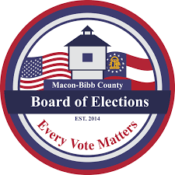
Absentee ballot applications can be requested and returned by the following methods:
- Contact the Macon-Bibb County Board of Elections @ 478-621-6622
- Complete an application electronically, by mail or in person
- By Mail: P. O. Box 6297 Macon GA 31208
- Email: absentee@maconbibb.us Or Fax: 478-621-6119

Absentee ballot applications are also available on the following websites:
Macon-Bibb County Board of Elections: http://www.maconbibb.us/board-of-elections-2/
Secretary of State My Voter Page (MVP): http://www.mvp.sos.ga.gov
Secretary of State Website: https://sos.ga.gov/admin/files/Absentee_Ballot_Application_2018.pdf

Voters who already participated in the presidential primary will receive ballots with other races during the May 19 election. Voters who haven't yet participated will receive ballots that include both presidential candidates and other candidates.

MACON-BIBB COUNTY BOARD OF ELECTIONS
2525 PIO NONO AVE., SUITE 1200, MACON, GA 31206
PHONE: 478-621-6622 / FAX: 478-621-6119
https://www.maconbibb.us/board-of-elections-2/
VOTER INFORMATION UPDATE

2020 VOTER INFORMATION GUIDE

Advance In-Person Voting will begin on Monday, May 2, 2022


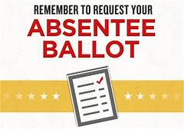
The Deadline to request an absentee ballot application is May 13, 2022 & the Runoff Election June 10, 2022

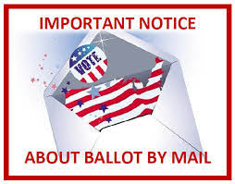

IN-PERSON ADVANCE VOTING LOCATIONS

MACON-BIBB COUNTY BOARD OF ELECTIONS
2525 PIO NONO AVE., SUITE 1200 MACON, GA 31206

ELAINE H. LUCAS SENIOR CENTER
132 WILLIE SMOKIE GLOVER DR.

THERON USSERY RECREATION CENTER – CLOSED DUE TO CONSTRUCTION

2022 STATE ELECTIONS & VOTER REGISTRATION CALENDAR
Continues
Elections | Voter Registration Deadline | Election Date
General Primary Runoff & Nonpartisan General  General Primary – Federal Runoff | April 25, 2022  May 23, 2022 | June 21, 2022
General Election/Special Election | October 11, 2022 | November 8, 2022
General Election/Special Election  Runoff  General Election – Federal Runoff | October 11, 2022  November 7, 2022 | December 6, 2022

Updated: 04/21/2022

