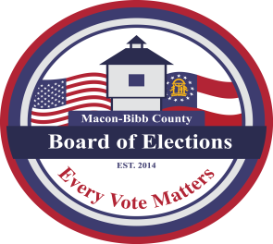
MACON-BIBB COUNTY
BOARD OF ELECTIONS
3661 EISENHOWER PARKWAY, SUITE MB101
MACON, GEORGIA 31206

Phone: (478) 621-6622
Fax: (478) 910-2365
Thomas Gillon
Election Supervisor
tgillon@maconbibb.us

GEORGIA, MACON-BIBB COUNTY (DRAFT)

CALL FOR NON-PARTISAN SPECIAL ELECTION FOR DISTRICT 5 COMMISSION SEAT

In pursuant to Notice is hereby given that, in accordance with O.C.G.A. §21-2-540(c) (1) (B), a Non-Partisan Special Election will be held in Macon-Bibb County, Georgia, on Tuesday, March 17, 2026, to elect a commissioner to fill the unexpired term of Commissioner Seth Clark for Macon-Bibb County Commission District 5. This seat is vacant due to resignation.

Only Voters that reside in the Commission District 5 will have this office listed on their ballot:
- Godrey 1- Dr. Robert J. Williams Complex (Ballard Hudson)
- Vineville 1 – Professional Learning Center
- Vineville 2 – Vineville United Methodist Church **(newly proposed change location)
- Vineville 3 – Glorious Hope Baptist Church
- Vineville 5 – Northminister Presbyterian Church
- Vineville 6 – Lutheran Church of the Redeemer

**The Vineville 2 polling precinct location was previously at the
First Christian Church

Candidate qualifying for the non-partisan special election will be held by the Elections Superintendent at the Macon-Bibb County Board of Elections main office located at 3661 Eisenhower Parkway, Suite MB101, Macon, Georgia 31206, beginning at noon on Wednesday, February 11, 2026, and ending at 5:30 p.m. on Friday, February 13, 2026. A qualifying fee of $450 must be paid as required by law O.C.G.A. §21-2-131(a)(1)(B).

All persons who are not registered to vote and who desire to vote in the Non-Partisan Special Election may register to vote by the deadline of February 16, 2026. Polls will be open from 7:00 a.m. until 7:00 p.m. on Election Day. Information concerning requests for absentee ballot applications can be found on Georgia Secretary of State website: http://www.mvp.sos.ga.gov or contact Macon-Bibb County Board of Elections office at 478-621-6622.

Robert Abbott, Chair
Macon-Bibb County Board of Elections

