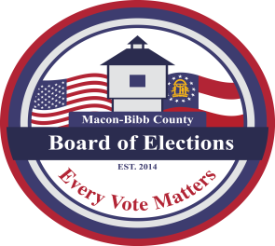
MACON-BIBB COUNTY
BOARD OF ELECTIONS
3661 EISENHOWER PKWY., STE MB101
MACON, GEORGIA 31206
Phone: (478) 621-6622
Fax: (478) 910-2365

Board Members  Robert Abbott  Chairperson  Tom Ellington  Vice-Chair  Barbara Boyer  Member  Karen Evans  Member  Mike Kaplan  Member  Thomas Gillon  Elections Supervisor | Agenda  Regular Board Meeting  October 16, 2025  5:00 P.M.  - Call Board Meeting to Order  Approval of Minutes for the September 18, 2025, meeting.  - Public Comments (Limited to TWO (2) Minutes)  - New Business  - Approval of Poll Managers for November 4, 2025, Special General Election  - Proposal to amend the Board By-laws  - Other Business  - Staff Reports  - Registered voter numbers  - Active: 106,316  - Inactive: 9,622  - Combined Total: 115,938  - This data is accurate as of date: 10/14/2025  - GARVIS Dashboard Report  - DDS Department Driver Services Applications – 465  - OLVR – Online Voter Registration Applications – 6  - Verification of Pending Voters –326  - Elections Supervisor – Thomas Gillon  - Status of early voting  - Legal Reports  - Public Comments (Limited to TWO (2) Minutes)  - Motion For Adjournment

