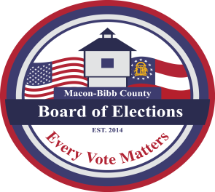
MACON-BIBB COUNTY
BOARD OF ELECTIONS
2525 PIO NONO AVENUE, SUITE 1200
MACON, GEORGIA 31206

Phone: (478) 621-6622
Fax: (478) 621-6119
Jeanetta R. Watson
ELECTIONS SUPERVISOR
jwatson@maconbibb.us

AGENDA & ZOOM MEETING INVITATION

EXECUTIVE SESSION MEETING
FOLLOWED BY A SPECIAL CALL MEETING
FRIDAY, MARCH 5, 2021

(An Executive Session meeting for discussion of personnel matters is not open to the public) The public will be permitted access to enter the meeting after the close of the Executive Session meeting.

EXECUTIVE SESSION

CALL TO ORDER: Mike Kaplan, Chair called the Executive Session meeting to order at _____ a.m.

Motion to enter Executive Session by _____ seconded by ______

Motion to close Executive Session by _____ seconded by _____

CALL TO ORDER: Mike Kaplan, Chair called the Special Call meeting to order at ______ a.m.

SPECIAL CALL MEETING
- List of Nominees for the At-Large Member for the 2021 – 2023 2yr Term (ACTION)
(Nominations of persons not currently serving as a Board (Member must include the nominee’s resume)
List of Nominees for Board Member At-Large
(List recorded on a separate form)

Motion to submit a nominee or list of nominees to the County Commission for Appointment of the At-Large member.

ELECTION OF OFFICERS FOR APRIL 1, 2021 – MARCH 31, 2022
The election of officers will take place at the March 18, 2020 regular Board meeting.

ADJOURNMENT:

- Motion for Adjournment at _______ a.m. / p.m.

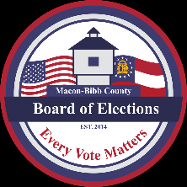

MACON-BIBB COUNTY BOARD OF ELECTIONS ZOOM MEETING INVITATION

Mike Kaplan, Chair is inviting you to a scheduled Zoom meeting
to be held Friday, March 5, 2021 at 10:30 a.m.

Board of Elections Executive Session: 10:00 a.m. – 10:30 a.m. – “Not Open to the Public”

Special Call Meeting (following the Executive Session at 10:30 a.m.) – “Open to the Public”

(Submission of nominees for the At-Large post for the 2021 – 2023 2-yr term)

Join Zoom Meeting
https://zoom.us/j/6837282880?pwd=Y0JEazBVQkFBc0Z5WXNjOTlQQmtOUT09

Meeting ID: 683 728 2880

Passcode: t8ek5Z

One tap mobile
+16465588656,,6837282880#,,,,*472814# US (New York)
+13017158592,,6837282880#,,,,*472814# US (Washington DC)

Dial by your location
+1 646 558 8656 US (New York)
+1 301 715 8592 US (Washington DC)
+1 312 626 6799 US (Chicago)
+1 669 900 9128 US (San Jose)
+1 253 215 8782 US (Tacoma)
+1 346 248 7799 US (Houston)
Meeting ID: 683 728 2880
Passcode: 472814
Find your local number: https://zoom.us/u/atJQMHa8u

