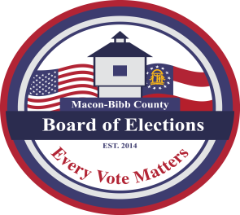
MACON-BIBB COUNTY
BOARD OF ELECTIONS
3661 EISENHOWER PKWY., STE MB101
MACON, GEORGIA 31206
Phone: (478) 621-6622
Fax: (478) 910-2365

Board Members  Robert Abbott  Chairperson  Tom Ellington  Vice-Chair  Barbara Boyer  Member  Karen Evans  Member  Mike Kaplan  Member  Thomas Gillon  Elections Supervisor | Agenda  Special Called Board Meeting  March 11, 2026  4:00 P.M.  - Call for Board Special Call Meeting to Order at: _____p.m.  - New Business  - Approval of Poll Managers Appointment for March 17, 2026,  Special Election (Commission District 5) O.C.G.A. 21-2-90  - Motion For Adjournment

