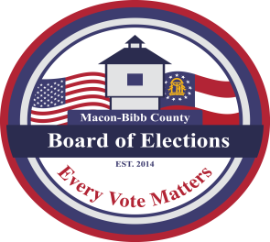

MACON-BIBB COUNTY
BOARD OF ELECTIONS
2525 PIO NONO AVENUE, SUITE 1200
MACON, GEORGIA 31206
Phone: (478) 621-6622
Fax: (478) 621-6119

Board Members  Michael “Mike” Kaplan  Chairman  Karen Evans-Daniels  Vice-Chair  Joel Hazard  Member  Darius D. Maynard  Member  Herbert Spangler  Member  Thomas Gillon  Interim Elections Supervisor | Agenda  Special Called Board Meeting  April 25, 2022  5:00 P.M.  - Call Board Meeting to Order  - Executive Session  - To discuss personnel matters.  - Discussion of the Elections Supervisor position  IV. Motion for Adjournment

To Join Special Called Board Meeting:
https://zoom.us/j/92181952475?pwd=NHkvU25TaERrZkZZbHhjK09NMVZhQT09

