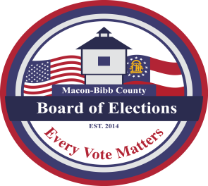
MACON-BIBB COUNTY
BOARD OF ELECTIONS
3661 Eisenhower Parkway, Ste. MB101
Macon, GA. 31206

Phone: (478) 621-6622
Fax: (478) 910-2365
Thomas Gillon
ELECTIONS SUPERVISOR
tgillon@maconbibb.us

GEORGIA, BIBB COUNTY

OFFICIAL NOTICE TO VOTERS OF PRECINCT HOWARD 3 POLLING PLACE CHANGE

The Macon-Bibb County Board of Elections hereby gives notice pursuant to O.C.G.A. 21-2-262(c) & 21-2-265 to permanent change from Rock Springs Church (formerly Mabel White Church) located at 1415 Bass Road, Macon, GA 31210 which is the polling place for precinct Howard 3 to the North Macon Presbyterian Church located at 5707 Rivoli Drive, Macon, GA 31210.

This change was approved at the Board’s meeting on Thursday, May 15, 2025. Establishing this change was due to Rock Springs Church (formerly Mabel White Baptist Church) unresponsive commitment of agreement as a polling site for Election Day. This change shall continue with June 17, 2025, Special Primary Election and going forward.

Karen Evans
Board of Elections Chair


